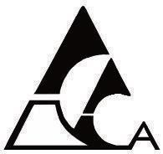
Alberta Community Art Clubs Association
Society No. 500053301
Registered Charity No. 8984 20948 RR001

VIBE 2026
Artist's Information
Artist's Name
Phone Number
address
city/town
postal code
email

Talent Levels - Circle entries) Youth Beginner Intermediate Advanced Masters Signature
Title | Category | Size | Medium | Entry Fee
Totals

Registration - Youth (15 – 18 Years old - $10) Beginner to Signature Talent Level - ($15) Medium/Categories: (2D - paintings/drawings), SC (Sculpture), DA-I (Digital Art Illustration) DA-M (Digital Art Photo Manipulation), FA (Fibre Arts)

